Digital Portfolio 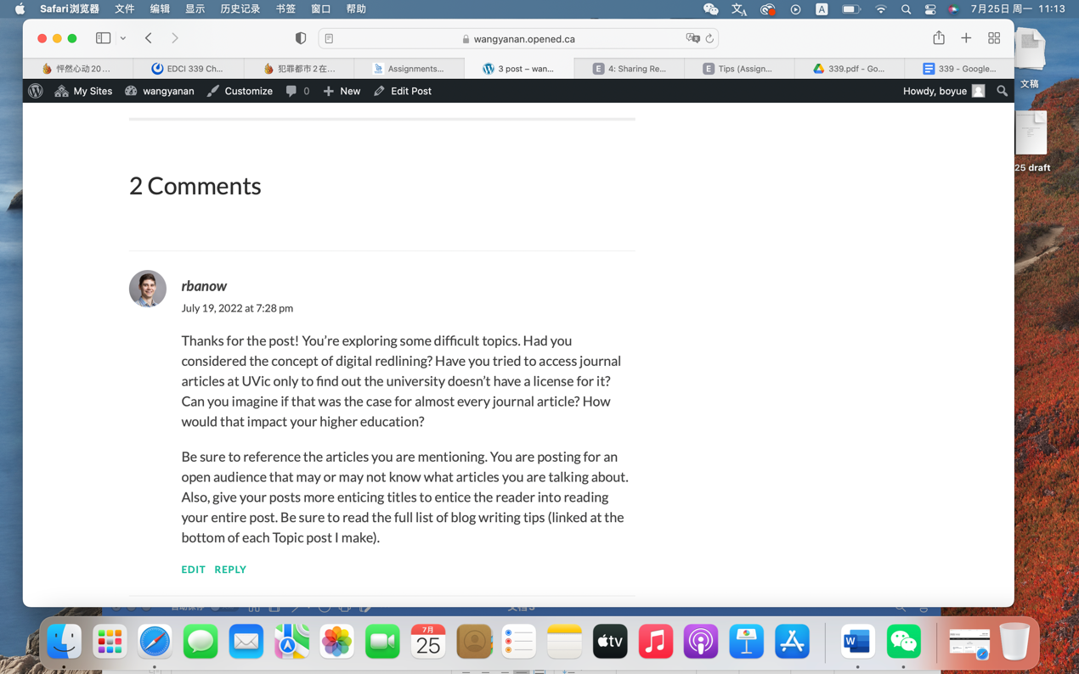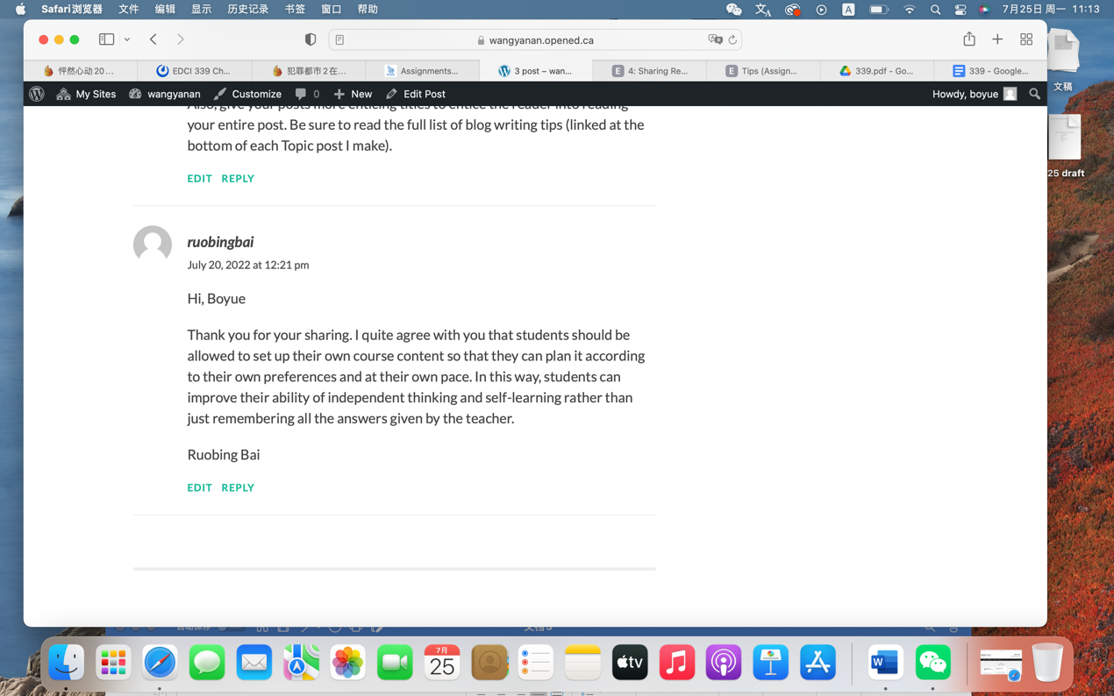
1, During the course, I did learn a lot from weekly blog post, I watched the comment from pod members and instructor. This is Topic3 Equity and access feedback.
2. From this, i learned a lot of open education concepts and how they can help students during the study.
3. This learning contributed to my development of enhance the understanding of open learning and open education.
4. This learning matters to me because I also learned of privacy during the open technology. And I got so many things about how important data for us and how to make it safer.
Part2 https://wangyanan.opened.ca/topic3-equity-and-access/(Updated post)
https://wangyanan.opened.ca/topic-3-post/(Orignal post)
I did more considerations on digital reddling and think about how this can impact the higher education. I also used the Uvic example during the Updated post.
I did some changes because I got feedback from instructor, I realized I missed some parts when I first time to post it.

